

Studienarbeit ISO 15118

By Alexander Barth & Michael Röhrich

**Table of Contents**

**1** **task 3**

*1.1* *Task of the project 3*

*1.2* *Why does the ISO 15118 3*

*1.3* *End of the project 4*

|  |  |  |
| --- | --- | --- |
| **2** **Pr** | **ogramme** | **6** |
| *2.1* | *Mindjet* | *6* |
| *2.2* | *Eclipse* | *6* |

**3** **The ISO 15118 Code 9**

*3.1* *Procedure of incorporation 9*

**4** **Using the ISO standards 12**

*4.1* *ISO 15118 Part 1 12*

4.1.1 Use of the stacks and existing features 12

4.1.2 Actors of communication 12

4.1.3 communication process 13

4.1.4 Explanation Annex A 14

4.1.5 Explanation Annex B 15

4.1.6 Explanation Annex C (charging scenarios) 15

*4.2* *ISO 2: 15*

4.2.1 safety 15

4.2.2 PnC & EIM 16

4.2.3 Required signals of the charge type 17

4.2.4 Response messages 19

4.2.5 state machine 20

4.2.6 Flow diagram of the communication 23

4.2.7 Annex A 25

4.2.8 Other attachments 25

**5 Structure Overview of messages 26**

*5.1 Structure of the document 26*

**6 sample program 28**

AIGURE 1: UMGEBUNGSVARIABLEN PUT .................................................. ........................................ 7

AIGURE 2: ECLIPS eETTINGS 1 ................................................. ................................................ 8th

AIGURE 3: ECLIPS eETTINGS 2 ................................................. ................................................ 8th

AIGURE 4: AACTORS OF KCOMMUNICATION (See (1), SAGE 14) ................................................ ........ 12

AIGURE 5: USE CASE ELEMENTS (See (1), SAGE 16) ................................................ ........................ 13

AIGURE 6: UNTERSCHRITTE THE USE CASES (See (1), SAGE 16) ................................................ ...... 14

AIGURE 7: EIM & PNC (See (2), SAGE 116) ................................................ .................................... 16

AIGURE 8: BENÖTIGE SIGNALE (See (2), SAGE 117) ................................................ ........................ 17

AIGURE 9: ZEITLICHES VRECEIVED FROM BOTSCHAFTEN (See (2), SAGE 145) .................................... 18

AIGURE 10: RESPONSE CODES (See (2), SAGE 153) ................................................ ....................... 19

AIGURE 11: ZUSTANDSAUTOMAT EVCC (See (2), SAGE 159) ................................................ .......... 21

AIGURE 12: ZUSTANDSAUTOMAT SECC (See (2), SAGE 167) ................................................ .......... 22

AIGURE 13: ABLAUFDIAGRAMM AC, EIM (TEIL 1) (See (2), SAGE 171) ............................................. 23

AIGURE 14: ABLAUFDIAGRAMM AC, EIM (TEIL 2) (See (2), SAGE 172) ............................................. 24

AIGURE 15: NEWS AND USE CASES (See (2), SAGE 180) ................................................ ..... 25

AIGURE 16: UML CHART TOTAL (MINDJET) ................................................. .................................... 27

AIGURE 17: BXAMPLE- BOTSCHAFT OFF UML CHARD (MINDJET) ................................................. ....... 28

AIGURE 18: BEISPIELPROGRAMM BILD 1 ................................................. ............................................ 29

AIGURE 19: BEISPIELPROGRAMM BILD 2 ...................................... F**EHLER! TEXTMARKE NOT DEFINED,**

AIGURE 20: BEISPIELPROGRAMM BILD 3 ................................................. ............................................ 31

AIGURE 21: BEISPIELPROGRAMM BILD 4 ................................................. ............................................ 31

AIGURE 22: BEISPIELPROGRAMM BILD 5 ................................................. ............................................ 33

AIGURE 23: BEISPIELPROGRAMM BILD 6 ................................................. ............................................ 34

AIGURE 24: BEISPIELPROGRAMM BILD 7 ................................................. ............................................ 34

AIGURE 25: BEISPIELPROGRAMM BILD 8th ................................................. ............................................ 35

AIGURE 26: BEISPIELPROGRAMM BILD 9 ................................................. ............................................ 36

AIGURE 27: BEISPIELPROGRAMM BILD 10 ................................................. .......................................... 36

AIGURE 28: BEISPIELPROGRAMM BILD 11 ................................................. .......................................... 37

**1 Task**

**1.1 Task of the project**

The aim of the work:

The flow of communication between electric vehicles and the charging station to be displayed. With the existing communication stack, a program to be written, the communication between the devices can be identified by means of which. The real functions to be displayed by run two programs written on different computers in parallel. This runs on a computer from the program of the vehicle and on the other computer, the program of the charging station. The computer will communicate via a freely selectable interface. Furthermore, was intended as an optional target, that the program should be subsequently loaded onto the computer system Raspberry Pi so as to simulate this.

**1.2 Why is there the ISO 15118**

In the presently oncoming energy transition is to be created, inter alia, a smart grid (smart grid). For this purpose, an optimal networking between power generators, power storage and electric consume is necessary. In the industry it is said that electric cars at best could even play a major role in this system. The reason for this is that electric cars (the only purchase electricity when much renewable energy is available) both controllable consumers, both as accumulators for storing the excess energy, and even as a generating unit (feedback / feed-in of reactive power) can be considered.

To meet these requirements, we need a powerful communication protocol with which to communicate the electric cars with charging stations and the underlying infrastructure and the computer systems. Also in the future will continue to play a major role, the issue of security, therefore, is the basis for the communication interception secure and encrypted

Communication necessary. For the standardization of communication, the eight-part standard ISO / IEC 15118 was developed.

Of the Kommunikationsstack of the ISO can unthe of the page

[**Http://Openv2G,sOurceforGe,net**](http://openv2g.sourceforge.net/) downloaded.

**1.3 end of the project**

Project Management:

At the beginning of project management, we set up for the individual steps each work package. With these steps, we planned to complete the project. First, it was planned that there is a learning curve for incorporation into the ISO 15118 (ISO 15118 Part 1) & (ISO 15118 Part 2), and the communication stack. Furthermore, there should be a training in Linux, and in the computer system Raspberry Pi.

Adaptation of objectives:

In a subsequent meeting with the client has been clear that we are not all achieve the above objectives. It turned out that even the incorporation would take a long time to complete. Therefore it was agreed that we primarily incorporate us in the ISO 15118th As a result of this work, the ISO 15118 should be explained with reference to the need to pages within the standard in order to facilitate a subsequent programming. In addition, the existing sample project within the ISO is a brief explanation.

Adapting priorities - new procedure:

As mentioned turned over the incorporation into the ISO 15118 out that even the incorporation represents a considerable amount of time. Among other things, because the documentation of ISO distributed to several hundred pages. We have found that the structure of the communication stack is very complex.

Therefore, we decided a tree diagram / UML create diagram by showing which messages and signals between the electric vehicle and the charging station are needed. The single ones

Communication steps and their sub-items are placed here graphically among themselves. The individual steps are each a descriptive comment was inserted. In addition to describing the dimensions of the message will be held in this commentary also equal. That is, it is recorded in any form, such as String, Char, or the like, the variable is expected.

**2 programs**

**2.1 Mindjet**

Mindjet is a software with which you can create mind maps. Mind Maps are graphic representations with boxes and arrows to order complicated structures represent tidy. Since the structure used in the ISO Part 2 of the messages is distributed very many pages, the Embassy building was modeled in a mind map. Herein all messages are visible at a glance and the amount of complexity is clearly visible. The description of each individual element has been retrieved from the ISO and added as a "note" in the mind map.

In Mindjet are import and export functions are available, eg in the mind map can be exported as a Word document or any Word documents can be imported.

**2.2 Eclipse**

Eclipse was used to the C code of ISO 15118 to compile. Here, however, there were some problems. It was tedious hinzubekommen the settings so that the code was run. The most important settings are called, which must be made in order to compile the code is possible in Eclipse.

Die RichtiGe InstallatiOnvOn Eclipse:

In Internet searches for "Eclipse for C and C ++". When you install the correct version must be selected, for example, for Windows 64-bit or MAC.

After the C and C ++ installation files down loaded, this is compressed in zip format. This should be unpacked on the C drive. For this purpose, should be on (C :) folder be created using a short folder name, such as "Eclipse".

In addition, the JDK (Java Development Kit) should be reinstalled. In addition, the latest MinGW compiler must be installed.

Following this, you should make the following changes in the system settings:

In the System Properties, the environment variable "Path" has reset

become.

VorgeHenbei WindOws 8:

Control Panel -> System and Security -> System -> Advanced Settings -> Environment Variables -> New

Then in "Variable Name" enter "Path".

And in "value of the variable" a link to MinGW compiler into copy. Beispiel:

C: \ Program Data \ Oracle \ Java \ javapath C: \ MinGW \ bin

The procedures can be taken from figure 1.

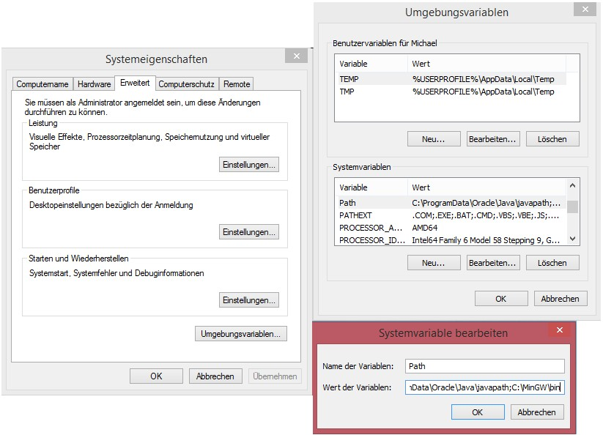

**Figure 1: set environment variables**

Having now installed Eclipse and the software of ISO15118 was imported nor settings in the properties (Properties) must be made. These settings can figure 2 and figure to be taken. 3

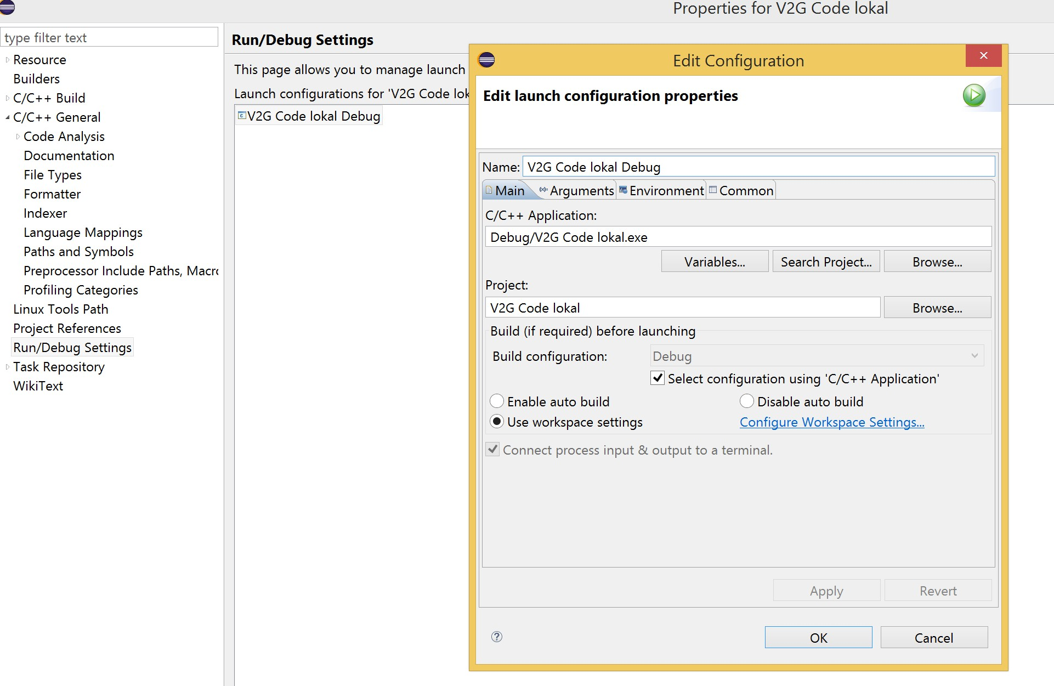

**Figure 2: Eclipse Settings 1**

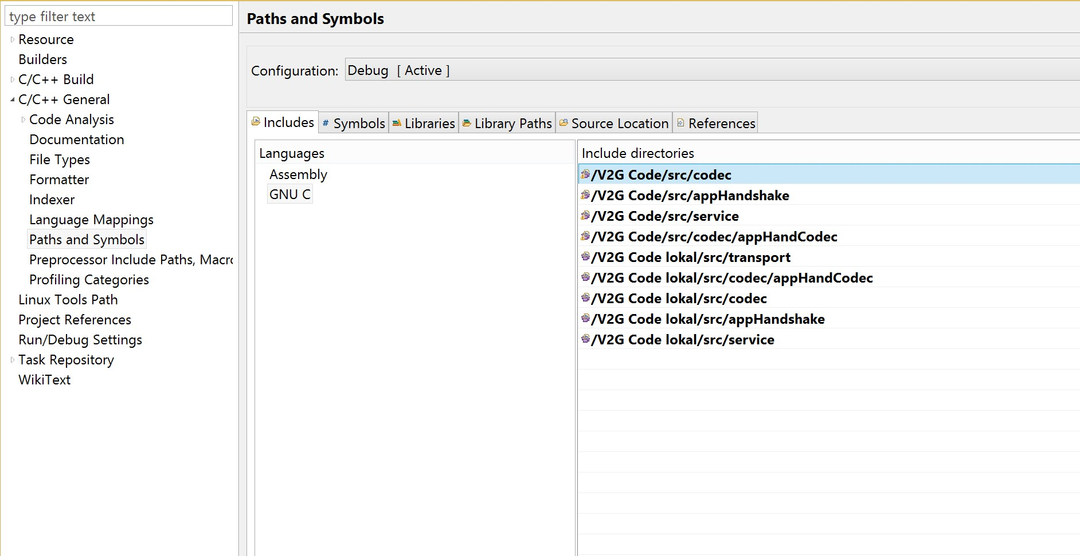

**Figure 3: Eclipse Settings 2**

**3 The ISO 15118 Code**

**3.1 Procedure of incorporation**

First we read the first part of ISO 15118, which contains general information. This was followed by the second part from Part 2 is the structure of communication removed.

First of all, you should be familiar with the technical terms and a few shortcuts to understand the explanations in the ISO. Below we have the most important terms explained, which were necessary to help navigate the ISO.

AutHenticatiOn:

Authentication is a process between the EVCC (Elektrofahrzeugs- communications regulator) and the SECC (supply of equipment communications regulator) or between the user and the EVSE (Elektrofahrzeugs- supply equipment). Here, the messages for validity / accuracy are checked.

Certificate:

The certificate is an electronic document, which uses a digital signature to a public key to bind with an identity.

CHarging scenariO:

A load scenario is a combination of use case elements (ways of

States of components).

COntract ID:

The contract identification number is a number that leads to the identification of a process between the parties. The contains information on the individual components. The ID can be vehicle-specific or customer-specific. The customer may be in this case, the driver or the owner of the vehicle.

Energy Transfer Type:

Is an element that the electric vehicle (EV) allows its desired energy transfer type in the event that the EVSE contains these select. It supports various ways of loading, and various plugs and sockets in accordance with IEC 62196th

IdentificatiOn:

Is a method to talk more product-specific information between the driver and EVCC. The driver has the option, for example data for the payment arrangements as to deposit as a credit card number. In return, the driver receives information on the technical characteristics of the system.

Primary ActOr:

Main actors are directly involved in the loading process.

Sales Tariff Table:

This table contains the prices for the electricity provided by the charging station available. This table shows supply and demand to possibly choose a skillful time for charging, for instance if the wind turbines or Photovoltaicanlagen produce maximum energy.

Secondary ActOr:

This is addition to actors that may be involved in the loading process, whether there is actually an investment, may also depend on the use case.

Use Case:

Describes a household case by showing, "who" something with the demand system and "what" can be started with the requested system.

The technical terms mentioned here are only the most used by us, if more technical terms are needed so they are in the ISO Part 1, to find, on page 2-9.

Fromkur easonnGen:

The most important abbreviations should be explained that were necessary to navigate the ISO.

**EP**: Electricity Provider => utilities

**EV**: Electro Vehicle => electric vehicle

**EVCC**: Electric Vehicle Communication Controller => electric vehicle

communications controller

**EVSE**: Electric Vehicle Supply Equipment => electric vehicle

supply equipment

**ECU**: Electronic Control Unit => Electronic control unit

**EIM**: External Identification Means => External identification Behelfsmittel

**MO**: Meter Operator => measuring service

**OEM**: Original Equipment Manufacturer => Manufacturers / OEMs

**PnC**: Plug and Charge => Inserting and Charging

**SECC**: Supply Equipment Communication Controller => Versorgungsausrüstungs- communications regulator

**V2G**: Vehicle to Grid => vehicle transport

The abbreviations listed here are only the most used by us, if more abbreviations are required, they are in the ISO Part 1, on page

10 to find 9 &.

On pages 3 to 6 of ISO 2 explanation of technical terms and breakdowns can be found on abbreviations. These were not much needed in the work to date, but may be relevant for future work.

**4 using the ISO - standards**

**4.1 ISO 15118 Part 1**

**4.1.1 Use of the stacks and existing features**

**4.1.2 actors of communication**

The following table shows the main stakeholders in the communication between electric vehicles and the charging station. The main actors are the vehicle, the charging station and the vehicle user. In the illustration, the vehicle system parts loader, controller and man-machine interface are subordinate. When electric vehicle include the electricity meter, the management of payment processes and the electrical contacts crucial functions.

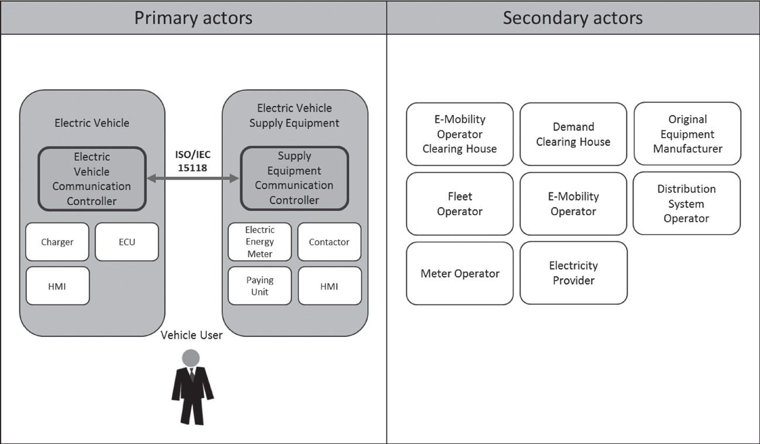

**Figure 4: actors of communication (See (ISO 15118 Part 1), page 14)**

**4.1.3 Communication sequence**

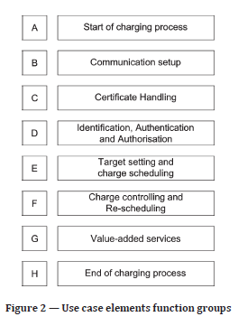

**Figure 5: Use case elements (See (ISO 15118 Part 1), page 16)**

The complete sequence of communication between the vehicle and the charging station from the beginning to the end of a charging process is divided into eight functional groups. Each communication process must include all eight steps, but the steps may vary from one another internally. The steps are described in ISO

1 on page 15 explains briefly but significantly, so will not describe all of it here.

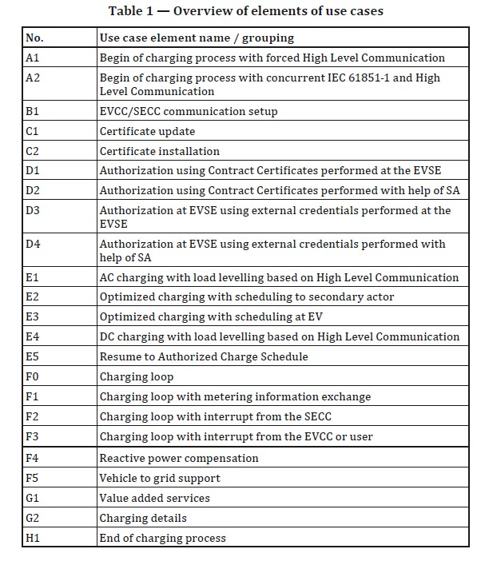

**Figure 6: Steps of use cases (See (ISO 15118 Part 1), page 16)**

In the above table, all existing sub-steps of the eight groups are listed. On pages 18-44, these are explained in detail.

**4.1.4 Explanation Annex A**

In the appendix to Annex A of ISO15118-Part 1 of the general construction of infrastructure is identified. in this connection become the different possibilitys on which

Communication levels is communicated. Furthermore, it is received that the establishment of the communication between a charging station and one or more vehicles may be carried out in several ways. In the illustration on page 49 is to see that the effort for simultaneous charging of several vehicles is far greater, because the vehicles in total draw a large current, and thus the flowing current must be divided between the vehicles.

**4.1.5 Explanation Annex B**

In the appendix to Annex B of ISO15118-Part1 the topic is dealt with security. Here, the demands on the security of communications are displayed.

**4.1.6 Explanation Annex C (charging scenarios)**

In Annex Annex C explains the use of the various use case elements based on application examples. In various structure trees is demonstrated what possible paths can be iterated for the different scenarios. It may be that some part of applications can not be used, they are then blackened in the ISO. An example of this is the presentation on page S.62, this is a load operation at a private socket. Of this total E2-E4, as these can not be used in this load scenario.

**4.2 ISO 2:**

**4.2.1 Security**

On page 10 is a description of various types of

to find security transfer.

The diagrams show the virtual and the semi-online communication. Here, only the safety-related points of the structures are discussed.

The table on page 14 shows the content and the structure of a certificate

On page 26, the V2G transport protocol is explained. It serves the messages between two instances / parties, which can work with them, to be transmitted.

**4.2.2 PnC & EIM**

On page 114, the difference between PnC and EIM is explained in more detail. This can of Figure 7 removed.

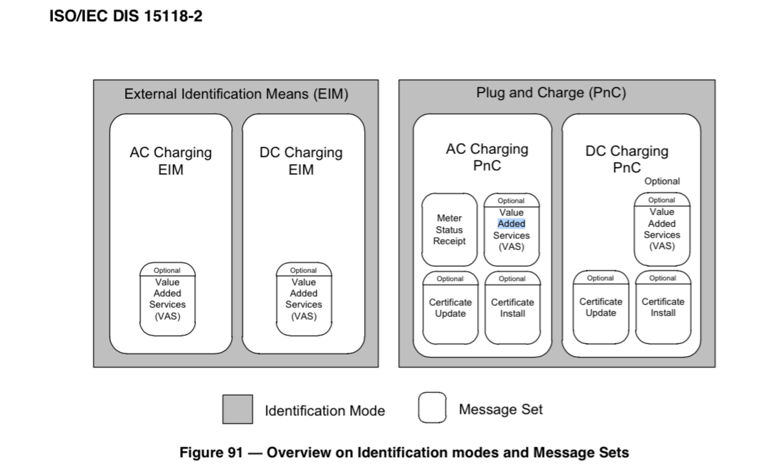

**Figure 7: EIM & PnC (See (ISO 15118 Part 2), page 116)**

**4.2.3 Required signals of the charge type**

In the tables on p 117 to 134 can be taken which signals "sent" in the nature of the charging process at the different charging processes have, "optional to send" are or "will not" need. On pages 135 to 141 are still to find information about each message sets from the tables. Furthermore describes each charging options.

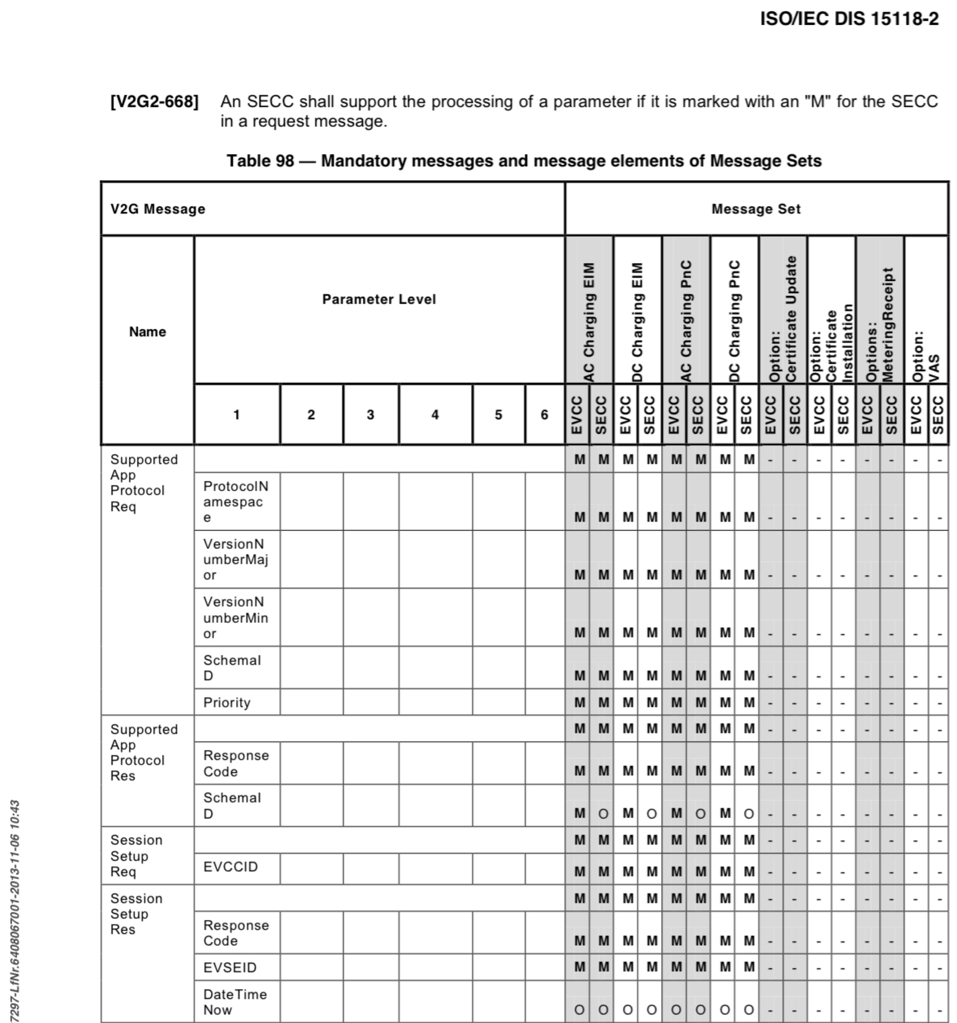

**Figure 8: Need signals (See (ISO 15118 Part 2), page 117)**

On pages 142-149, the communication timing is dealt. Here, the time intervals can be defined at any news of her previous message. Within these periods, messages must be fully transmitted. If this is not the case, the communication is terminated.

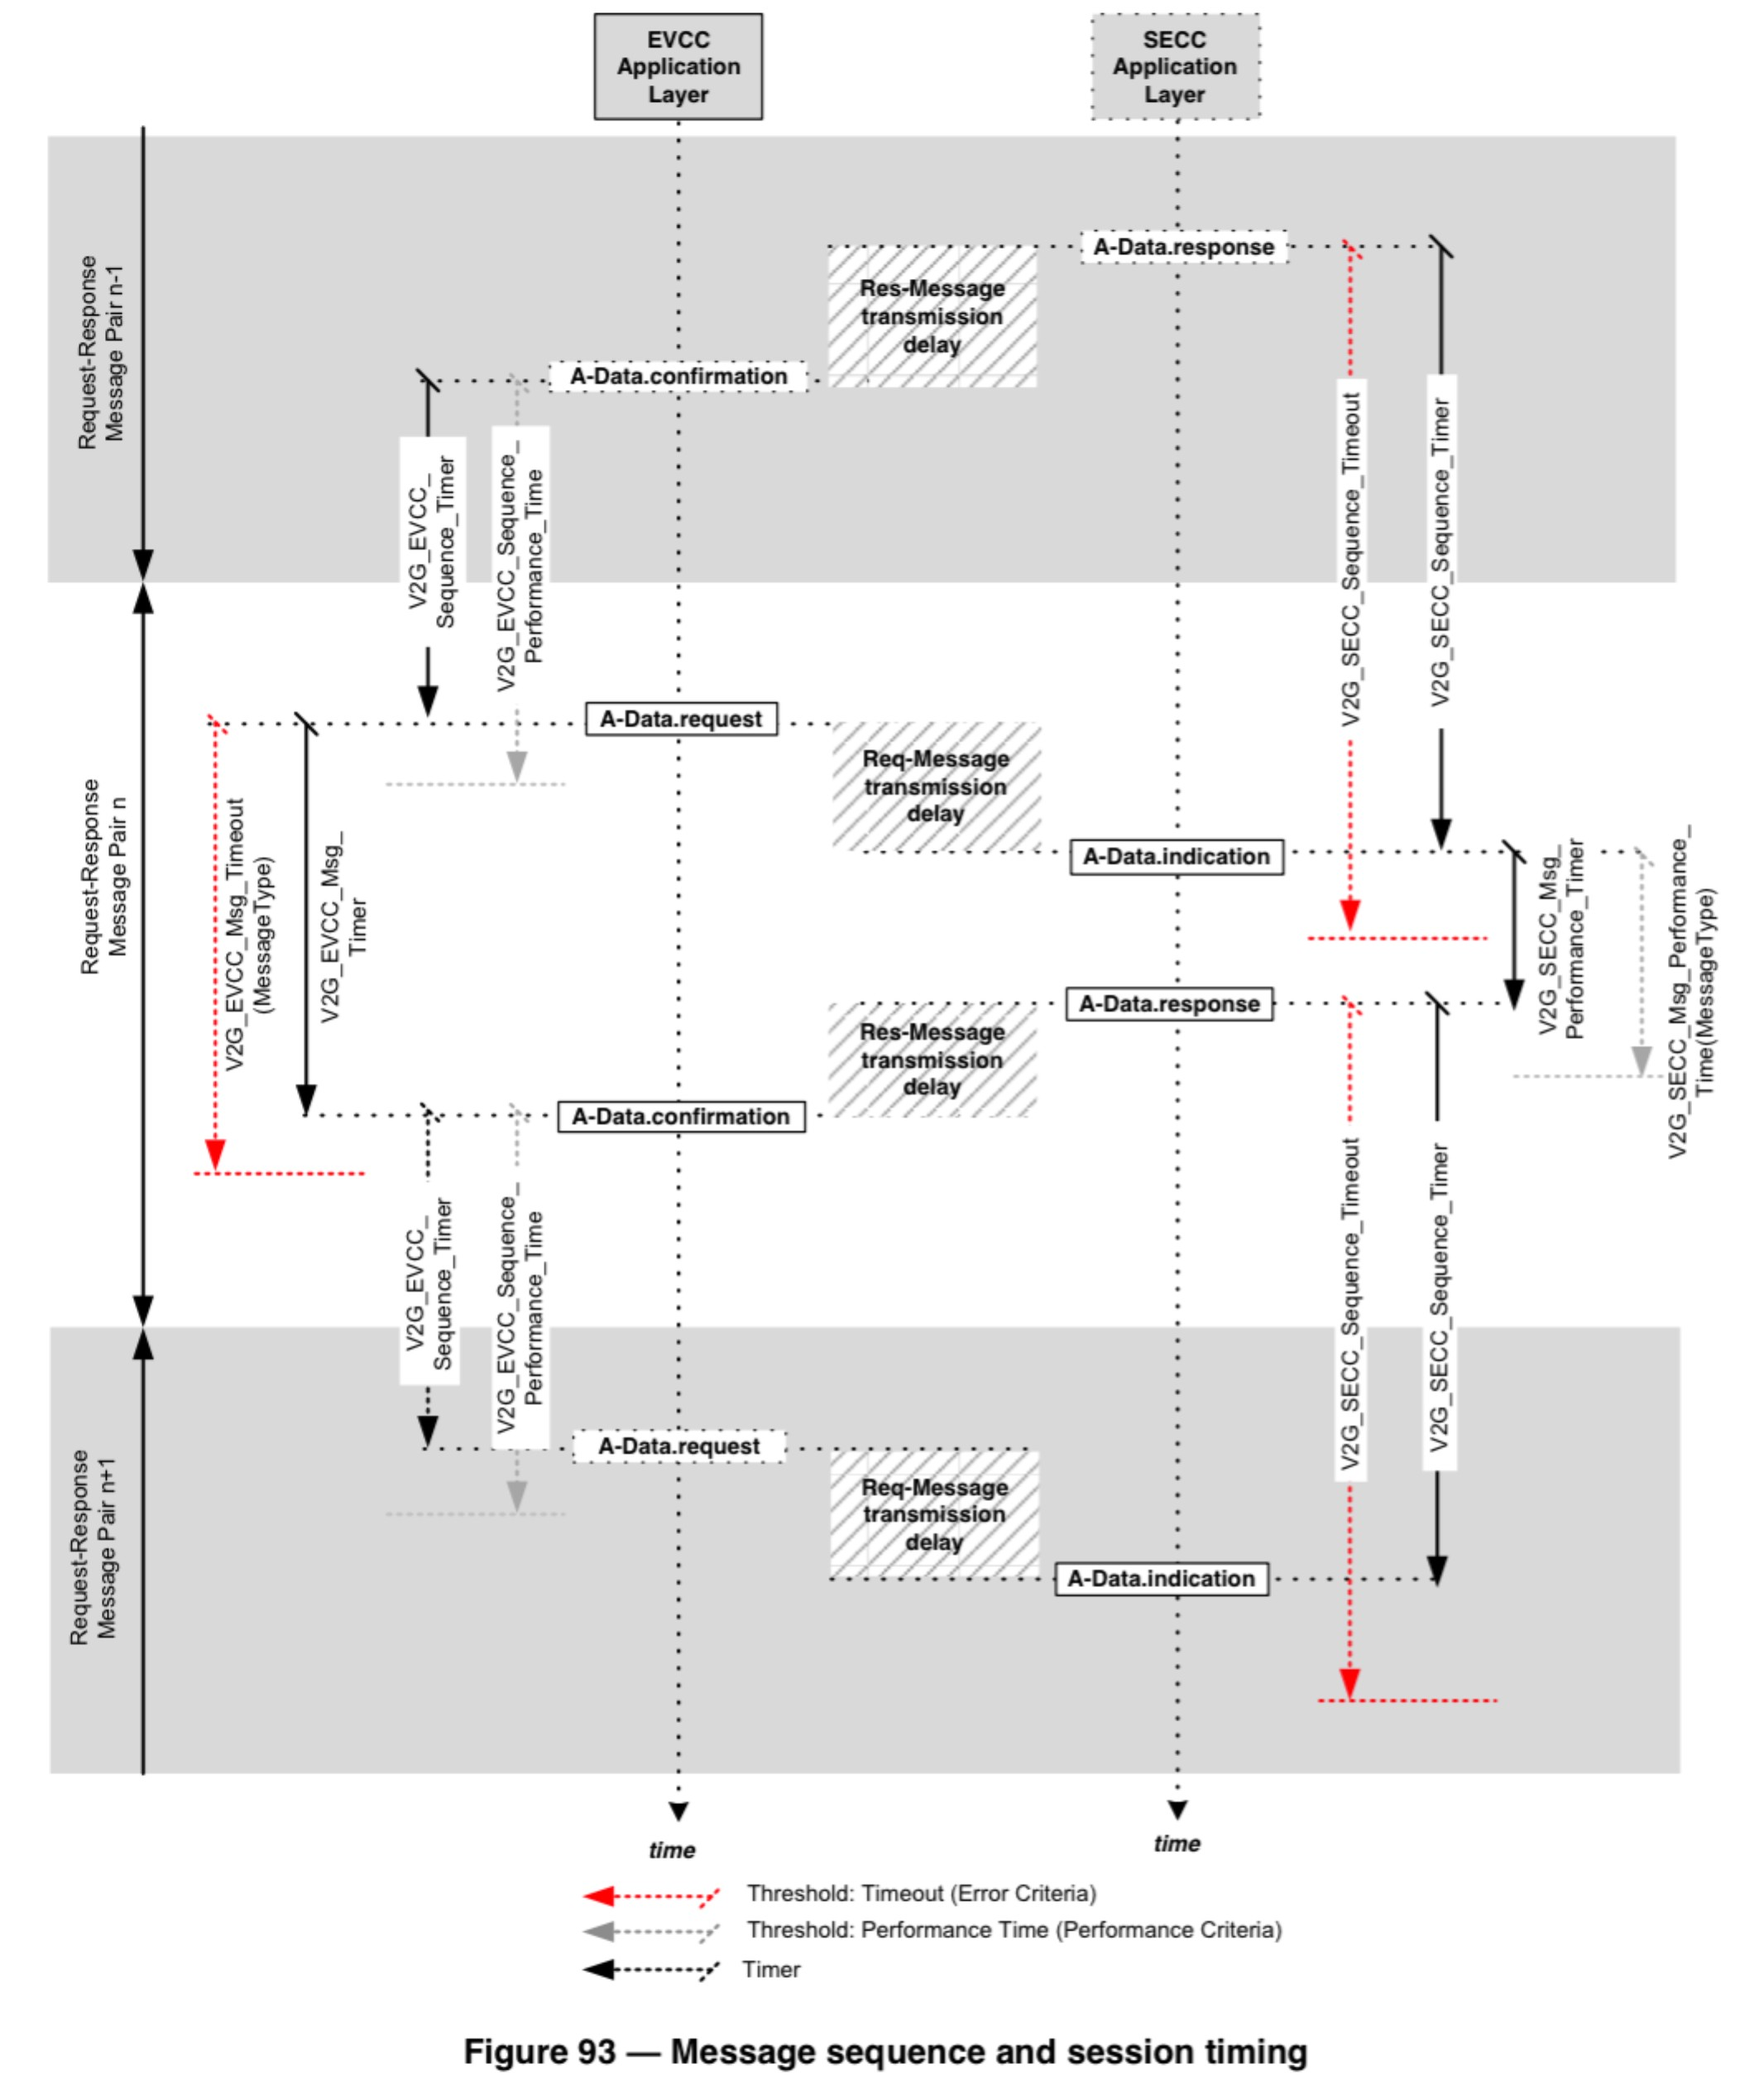

**Figure 9: Time behavior of messages (See (ISO 15118 Part 2), page 145)**

**4.2.4 Response - News**

On pages 149-155, the "table 106" is displayed, which predetermines the answer choices of response codes for each message. This clearly documents the error messages can be displayed.

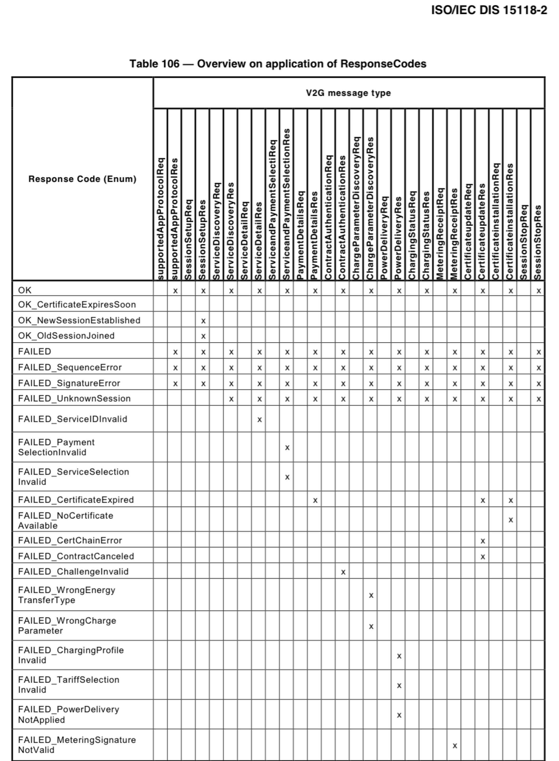

**Figure 10: Response Codes (See (ISO 15118 Part 2), page 153)**

**4.2.5 State Machines**

On page 155, the state machine will be described. In the following two images (Figure 11 & Figure 12), the state machine can be seen again for the SECC and the EVCC.

In the illustration of the SECC as a state machine, the states are each waiting for the request message of the EVCC. The arrows to move to the next state, the response messages of the SECC.

When EVCC the states are waiting for the response messages from the SECC respectively. The arrows represent the sending of the request messages.

Which arrow must be selected from a state and what these is described in the ISO on pages 155-170.

initial EVCC

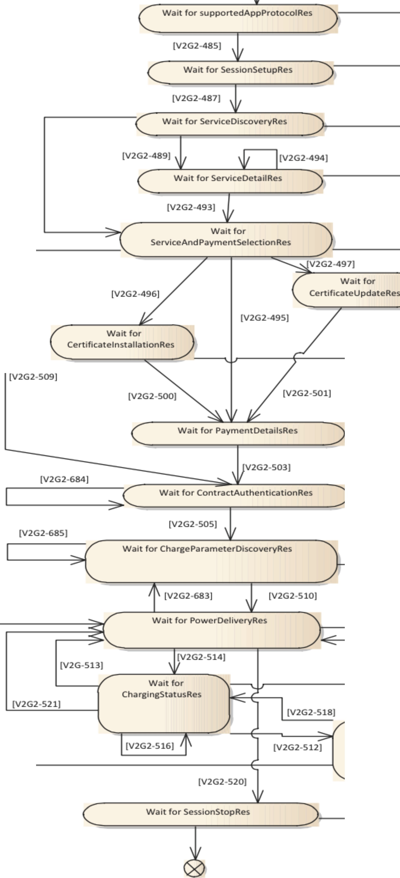

side

[V2G2-483)

[V2G2--484)

[V2G2-486)

[V2G2-488)

[V2G2-490)

(V2G2-519]



[V2G2-508)

Stop CoMMUNlcatisession on - No Error

[V2G2-522]

Wait for MeterlngRecelptRes

[V2G2-491)

[V2G2-492)

[V2G2-499)

[V2G2-498)

[V2G2502)

[V2G2-504)

[V2G2-506)

[V2G2-515)

[V2G2-5 l)

[V2G2-517)

[V2G2-507)

Stop Communicatlsession on - Error

Figure 95 EVCC Communication states for AC V2G messaging

Figure 11: State machine EVCC (See (ISO 15118 Part 2), page 159)

initialEVSE slde •

*w*

[V2G2 536]

Proc: ess (V2G2-540) Wait state for "" 'R-- - - - '(V-2"-G":2: _:5: _:3,8th.:c]:. ;

'-sup_rt •-d_A_ppp_•_otoil/ '-su _p_pO_r_te p_P_•_otO_1/). (2VG2-357L] _-1t- l

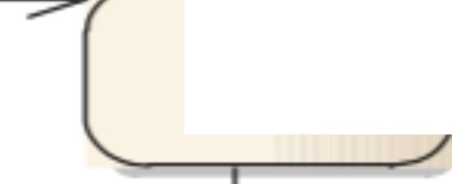

Process (V2G2-542) 1 ( '- Walt State *for )*" '- \ _--------- (V = 2G ::: 2: ..- 5:.: 3:. :: 8: ... L-- :;

( SesslonSetup

SesslonSetup (V2G2-537]

'---------

rampart State for '- \ ------- -'rv .._,;. 2G2;-.5: " '3' '8'-31..

|  |  |  |
| --- | --- | --- |
| --.-, -.ss ----.,. | ServkeO.sc:overy *)* | rv2G2-537l |
| ServkeDiscovery |  | rv2G2-S46 |

Servke ;;: s: t :: on. *or*

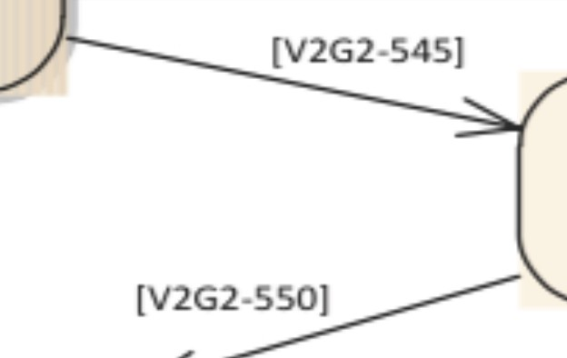

Servit: eAndPaymentSele <: t • on

>. (V2G2-538]

------- Rv; 2 G2-53 7L__ ,

V2G2-S47

*A .. (* Proc:ess service detail

-------- SSF ] V 2 G; 2-5 48] --------- /

Process \

ServlceAndPAymentSelectlon

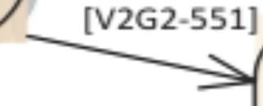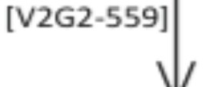

Walt State for PaymentOetalls or Contrac :: tAuthentlcatlon or

Certlflcatelnstallatlon or

V2G2 549

V2G2 552

(V2G2 S37)

Negative response Message

(V2G2-539]

CertlficateUpdate

J Process

Certlr.cateUpdate

(V2G2-562]

-----.-, ----- / ]V2G2-556

Process [V2G2-553) J

Cert • ficatelnstallatlon *../)'_E- :::::::::::: -----;: =:;:;: ;;: === 'Fr'*

(

I Mr> -. << 41st \1/ I (V2G2-558]

'0 *'V* rv> <:>-"71

Wait State for

PaymentOetalls *}*

L r (V "2" G "-2-. ;; 5 ;;; 55;:.. _ 1-31 1

(V2G2-538)

(V2G2-537] -

stop CommunlcaUon

Session· error

Process

PaymentOetalls

e ( l "> <;>" aJ

V2G2 561

lV2G2-5601 >

(V2G2-538]

Proc: ess

IV> r.>-<• 71

Wait State for

ContractAuthentlcation *) _*

(V2G2-537] -

Contrac: tAuthentic:atlon I YL '> L O'I

'------------- -----, (V2G 563]

V2G2-564

(V2G2-538]

".--w ,,,.-.,- - >. '\ ---------------- -31

Process "\. [V2G2-688) -J ChargePararneterOiscovery )

V2G2-537

Charge parameters Discovery (V2G2-S65 '-. / --------- "" "" " '" "'" - 11- 1

IV7 <:>, <• 1

*)* ]V2G2-573) );O

Walt Staufor

] V2G2-538]

1V2G2-56 '( Po :; :. 'V

IV7r.7, "71- *(*

PowerOehvery } ---------- - "" '- V'2G2- 537L -f - 3; ..

*---------------------------------- ----*

(

1

(V2G2-568 (V2G2-S67]

*)_* N? G?-576]

(V2G2-S74)

*r _* CwH_a,r, _G,in··G_S_ta·Ot_u·s

[V2G2-574) 1 -

[V2G2-569)

V2G2-538

") - = - = - = - = - = - = - = - = - = -I-V=2-G=2---5=3-7- =1- = - ::::: 1R- l

Proc: ess

Walt Sta te ror

charglngStatus *or*

PowerOellvery or

(V2G2-575] '-.

charglngStatus

1

IV2G2-snit

IIV2G2-5781

V2G2-537

[\

(V2G2-S80)

Walt State for IV2G2-5381

)

*/} --------- - -*

'----.------

meterlngRMF: IPt (V2G2 537] -

*\ jl*

[V2G2-S79]

Process

MeterlngRecelpt

Wait State fot '\.

session stop *}* [V2G2-S70l._

. - =: = _- =: _: _ =._ / '-; ':'; - cProcess Sessionstop)

QSJE( 1~~V2~~G~~2~~-5711 _ '---------------- V2 G25-721-;? ..

Error Fork

stop CommU.Nlcation Se.ulon • No Error

response F'ork

Figure 97-SECC Communication states for AC V2G messaging

Figure 12: State machine SECC (See (ISO 15118 Part 2), page 167)



AutOmOtive Systems EnGineerinG

**4.2.6 Flow diagram of the communication**

On pages 171-179 a sequence chart (Figure 13 & Figure

14) a communication sequence displayed without error. This each for AC and

DC, respectively PnC and EIM.

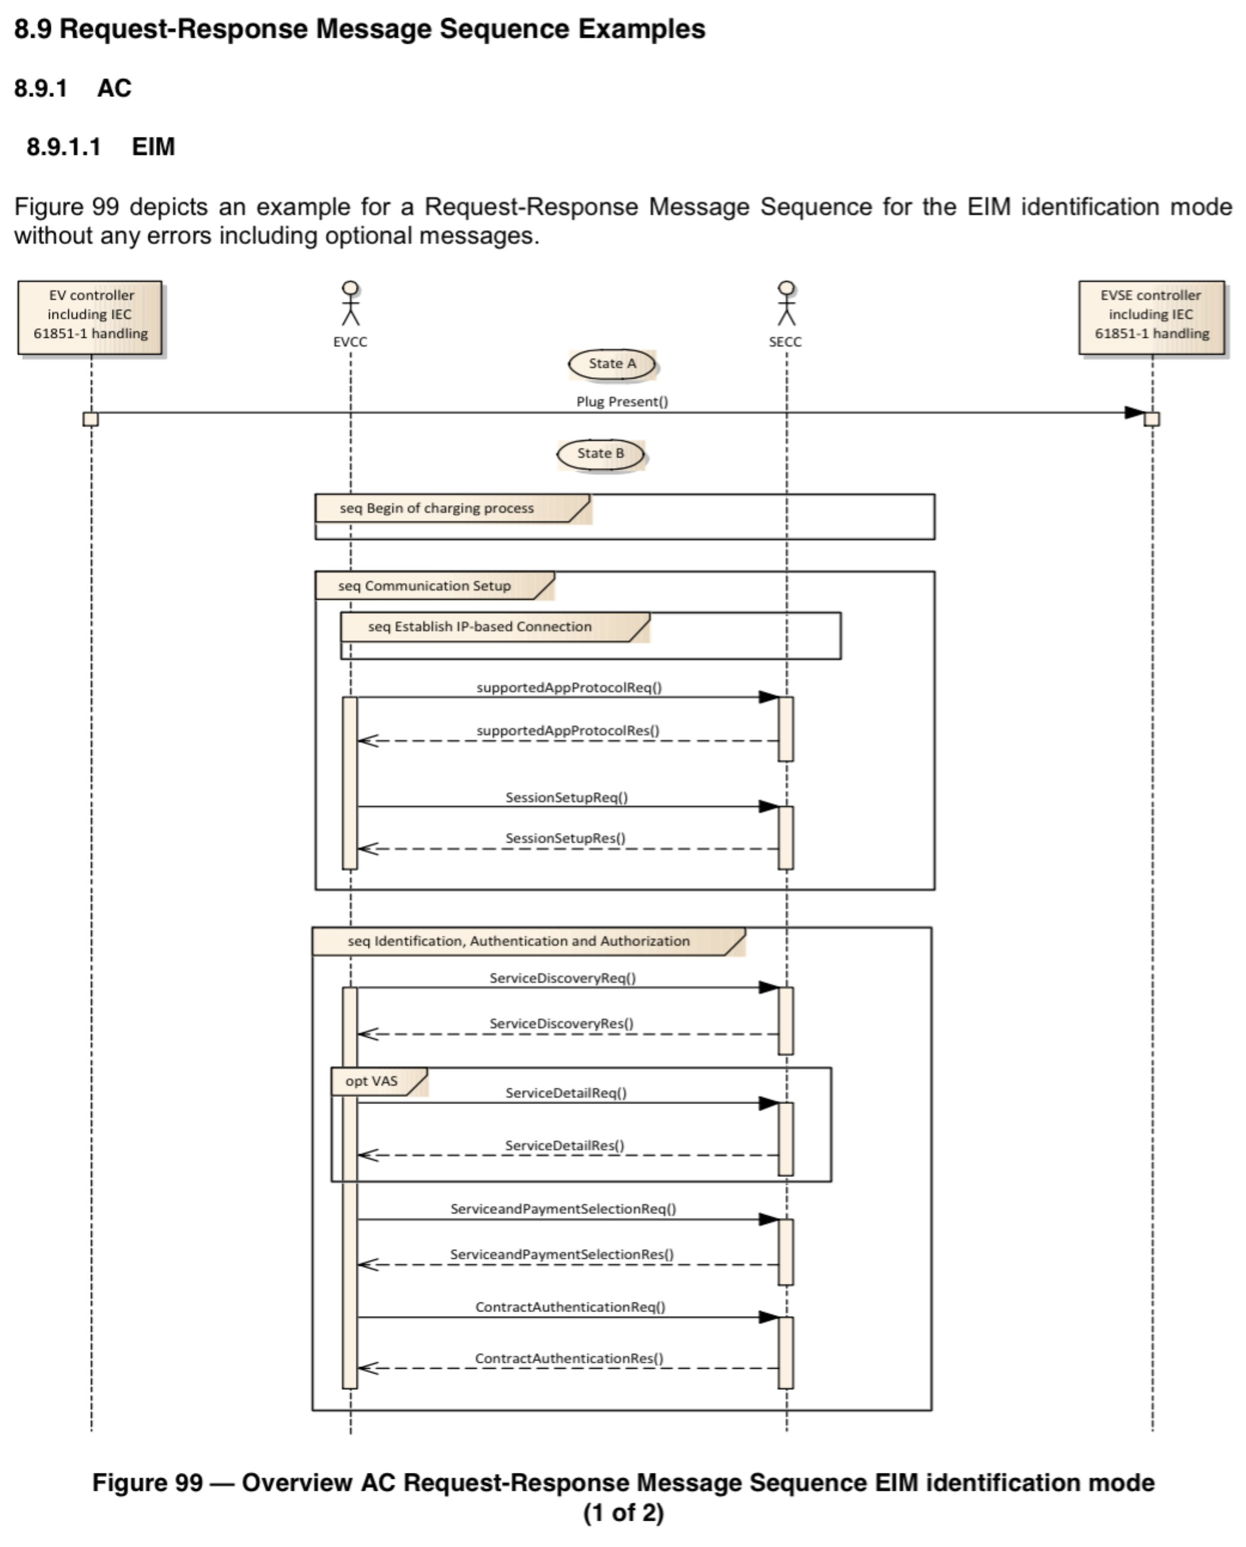

**Figure 13: Flowchart AC, EIM (Part 1) (See (ISO 15118 Part 2), page 171)**

**1-1-N**

COLLEGE HEILBRONN

automotivee systems Engineering **••: c • u uw**

EV ControllerincludIngiEC

61851-1Handling eVCC

I II I I

I

I

III I

seq Tbadet Setting ondcHa rge scHeduli nG /

SECC

EVSe Controller including IEC

61851-1handling

- r_! m _ !!! rQio!. •! :: i •. !! iJ_--

I ChargeParamterDiscoveryReq ()

I

: State C transition prior PowerDeliveryReq () l

l, J .. I I L., J

I I

IIIIIII PowerOeliveryReq () I

..0

Q

II

II

I I

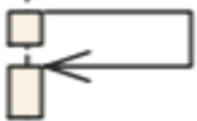

II Cleyelet

I I

II

I Contactors ()

O:<--------P-ow-ERO-el-iv-ery-Re-s (-) -------OI

I 1

I 1

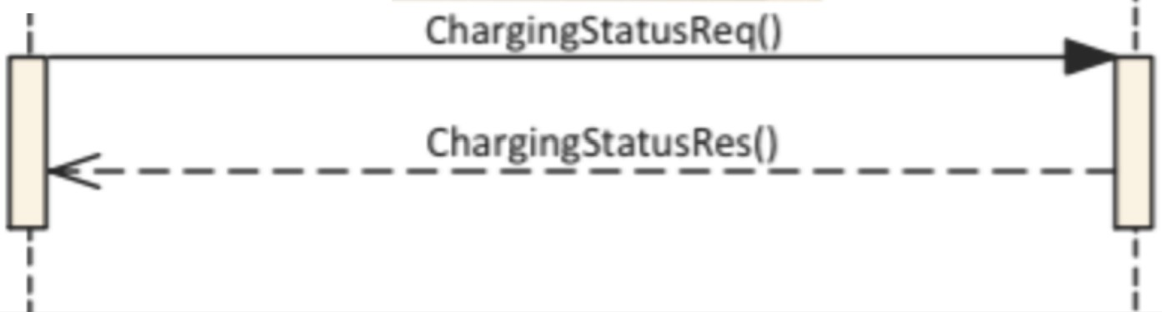

loop Charge controland Re-scheyoulinG _ /

1--.seq en_d_O__cH_a_rg'-i-n- 'G-pro ces_s_ // :

I: II

: PowerOeliveryReq () •

0

0 ..

IIIIII

II

Open

p

Contactors ()

Q1 <--------P-ow-er-D-e-liv-he-AER-s"----O 1



I I

l

1 State 8 Transition()

y

I State 8th I1

IIII II

1 SessionStopReq () ..:

- OE_R _ !! -

I

: 1 <

I

I IIII I

I

:

Figure 99- Overview AC Request-Response Message Sequence EIM identification mode

(2 of 2)

Figure 14: Flowchart AC, EIM (Part2) (See (ISO 15118 Part 2), page 172)

**4.2.7 Annex A**

Here is shown the block that contains the messages.

It shows which message set which use case involves elements.

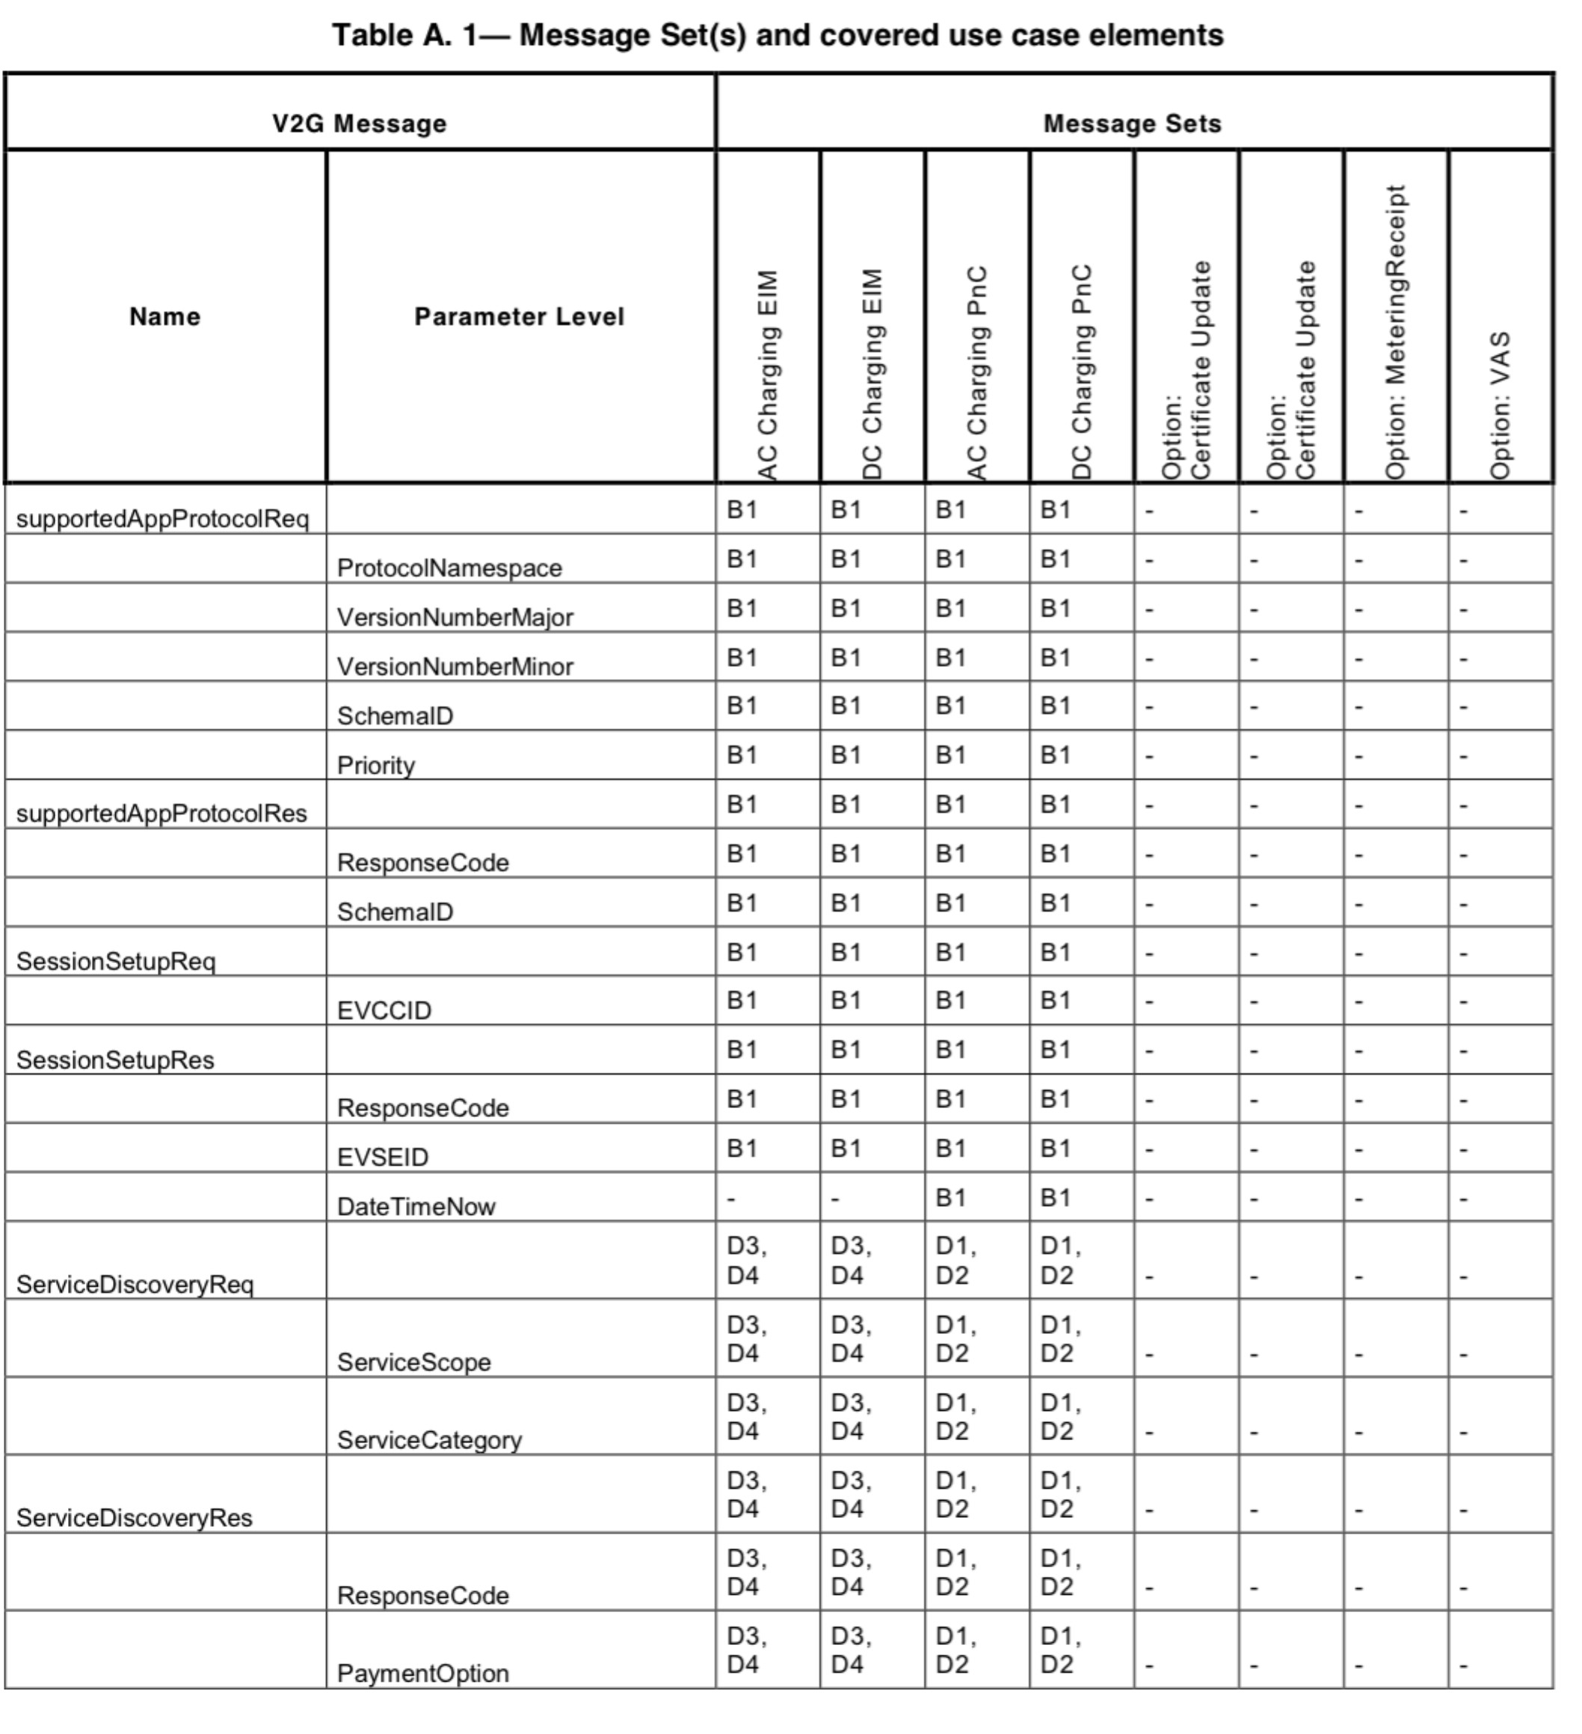

**Figure 15: Messages and use cases (See (ISO 15118 Part 2), page 180)**

**4.2.8 Other attachments**

Annexes Annex B to Annex K are no longer part of this documentation but could still contain other additional information.

**5 structure overview of messages**

**5.1 Structure of the document**

From page 45 to page 114 of the ISO (ISO 15118 Part 2), the individual messages are broken. These messages we have a closer look. For this purpose we have translated the descriptions into German and explains the data it contains accurate.

FathersärungautOmatisch erstelltes WOrd-DOkument:

First, the messages are explained, they are in the tree of the UML chart (Figure 16) of the top box. The statement will be briefly explained what happened at the embassy. Among them in the second level, the complex data types (eg Word document, 1.1 GenChallenge) may also contain smaller data types, explains. The data types included letz finally actually to be transmitted signals. It may also be included directly in the message signals to a data type subject (eg, Word document, 1.2 Id).

The present in the ISO observations of the above data types and signals were picked to the variables to explain. This statement is intended to help in the subsequent input of variables.

In the following diagram (Figure 16) is the complete tree of

To see messages that are used in the ISO 15118th

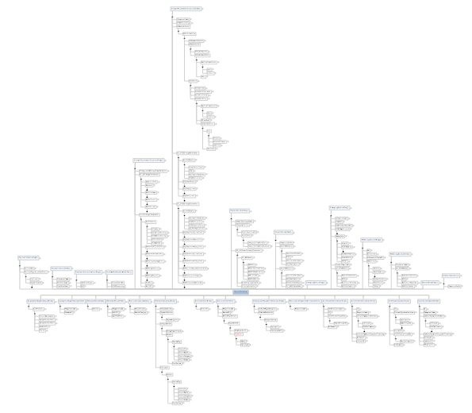

**Figure 16: UML chart Total (Mindjet)**

The following figure shows only one message can be seen, which is explained briefly below.

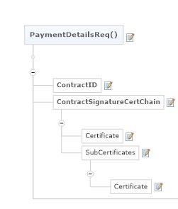

**Figure 17: sample message from UML chart (Mindjet)**

PaymentDetailsReq():

In the message "PaymentDetailsReq ()" of EVCC offers payment details, if the selected payment "Contract" is. The "signature certificate chain" and the "Contract id" of EVCC calls to send "challenge" the SECCD a. Here, the ContractID is a number that identifies the charging contract. The format for this purpose is defined in DIN 91286th Each description of each variable of the data type is always specified, here at "ContractID" this is a string with a maximum length of 24 characters. The "ContractSignatureCertChain" includes certificates and optional which also describe sub-certificates to communicate in this communication step.

**6 Sample Program**

This section discusses the existing sample program within the communication stack. In Figure 18, the main_service function, which is invoked by the main.c to find. Within this

three other functions are called. The appHandshake that ac_charging and dc_chargin. As the names suggest, is simulated in the first function of the handshake between the vehicle and charging station and another in the two the DC and AC charging. The rest is just an ad text in the console and as an explanation of the procedure.

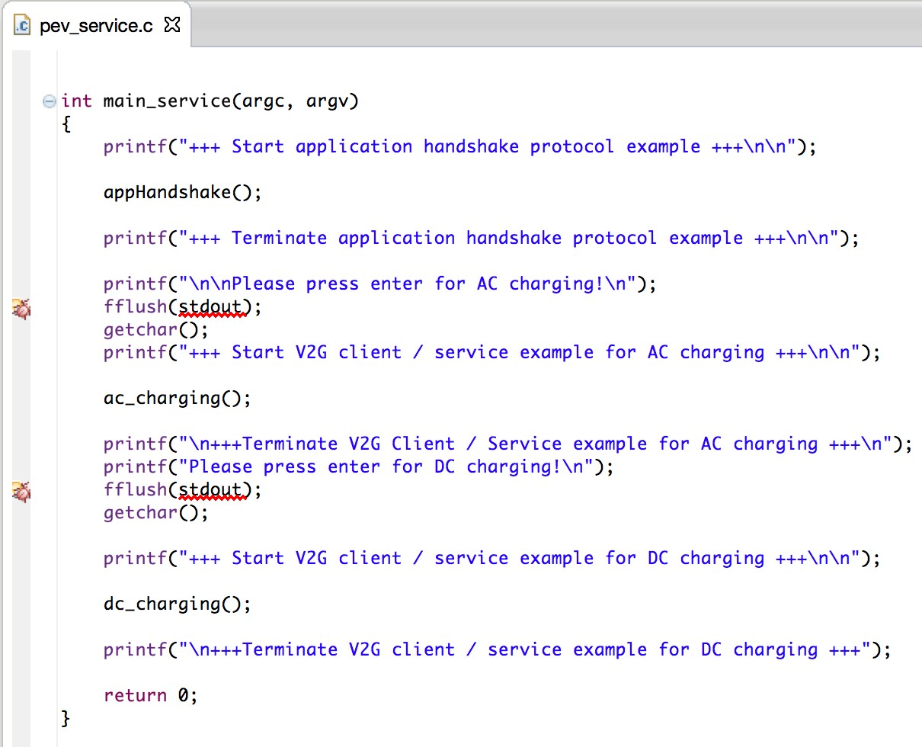

**Figure 18: Example Program Picture 1**

The Figure 20, Error! Reference source not found. and Figure 21 show the appHandshake function. In this, the parameters are filled and made the handshake.

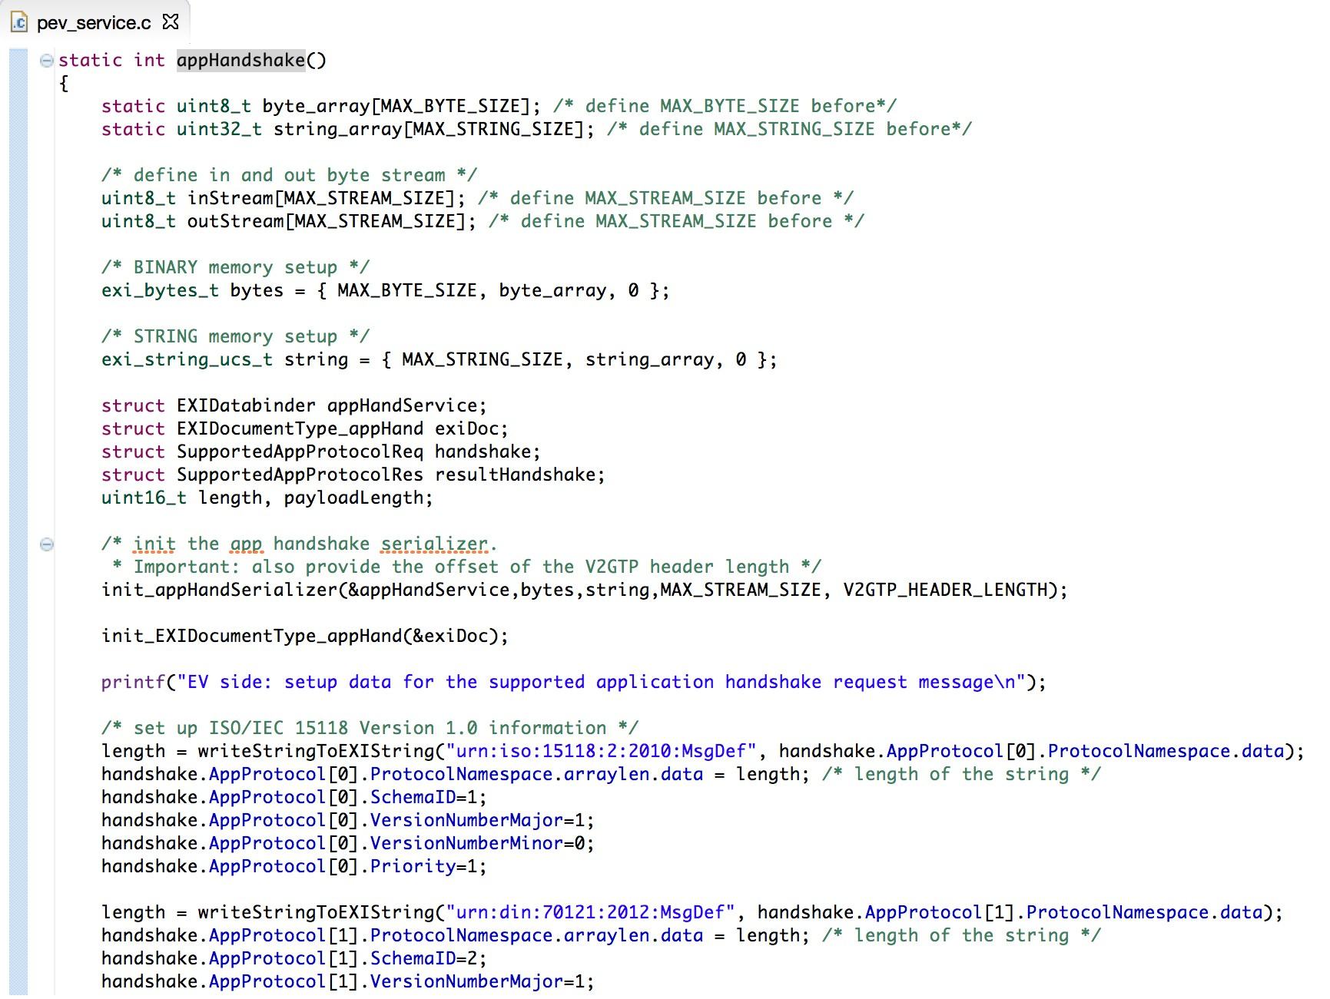

**Figure 19: Example Program Picture 2**

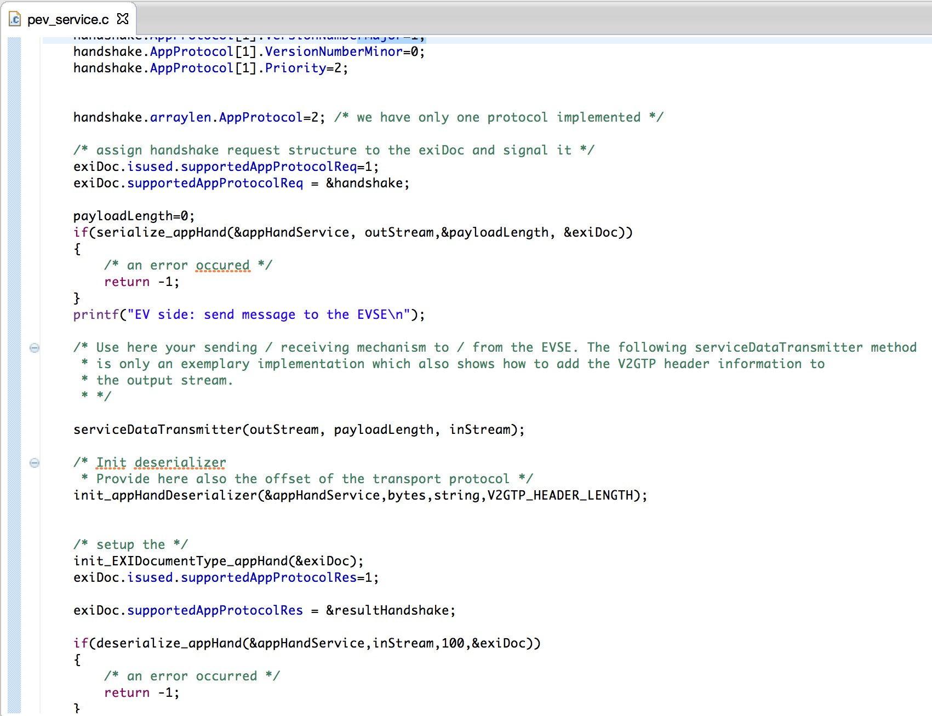

**Figure 20: Example Program Picture 3**

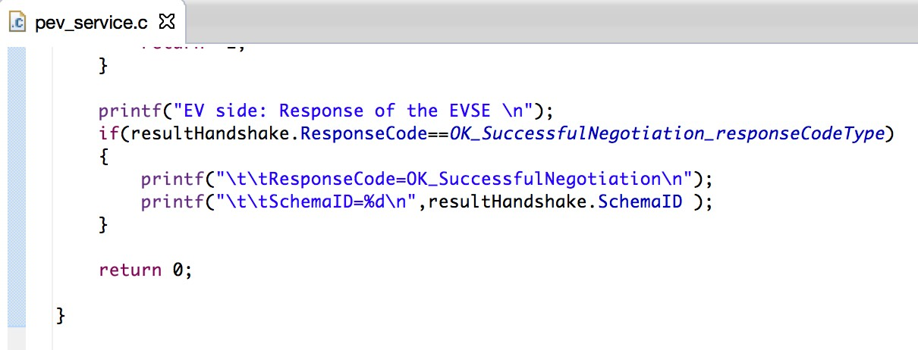

**Figure 21: Example Program Picture 4**

Figure 22 to Figure 28 show the code of ac_charging function. In the first step all the necessary messages are created as Struct. Now, with the init_v2gServiceClient the instream and declared outStream and the "service"

connected. With the prepare_sessionSetup function previously entered data session setup in the "service" are written struct. This is then transmitted through the service data transmitter function. The function must still partly programmed when an actual transfer will take place. Essentially, the data will always be filled, then written to the "service" and this then transmitting. Hereinafter, the communication will be described in a few features. These are the main functions of the rest is used to write the values ​​in the struct and outputting information to the console.

ac_charging:

init_v2gServiceClient

prepare_sesssionSetup à→ writes data to the "service"

service data transmitter à→ sends the "service" to the charging station prepare_serviceDiscovery

service data transmitter prepare_serviceDetail

service data transmitter prepare_paymentServiceSelektion

service data transmitter

...

According to this scheme the complete sample runs.

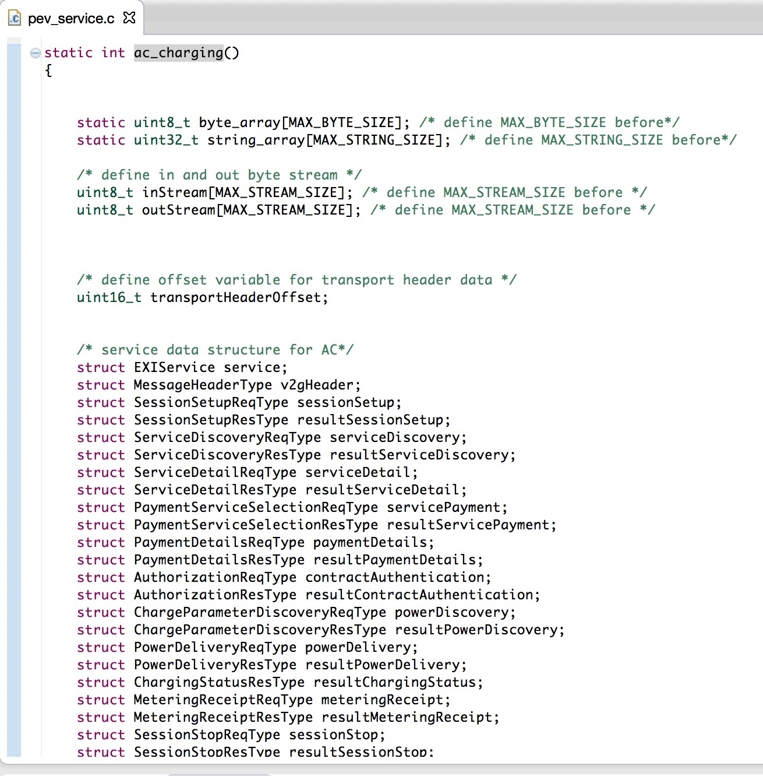

**Figure 22: Example Program Picture 5**

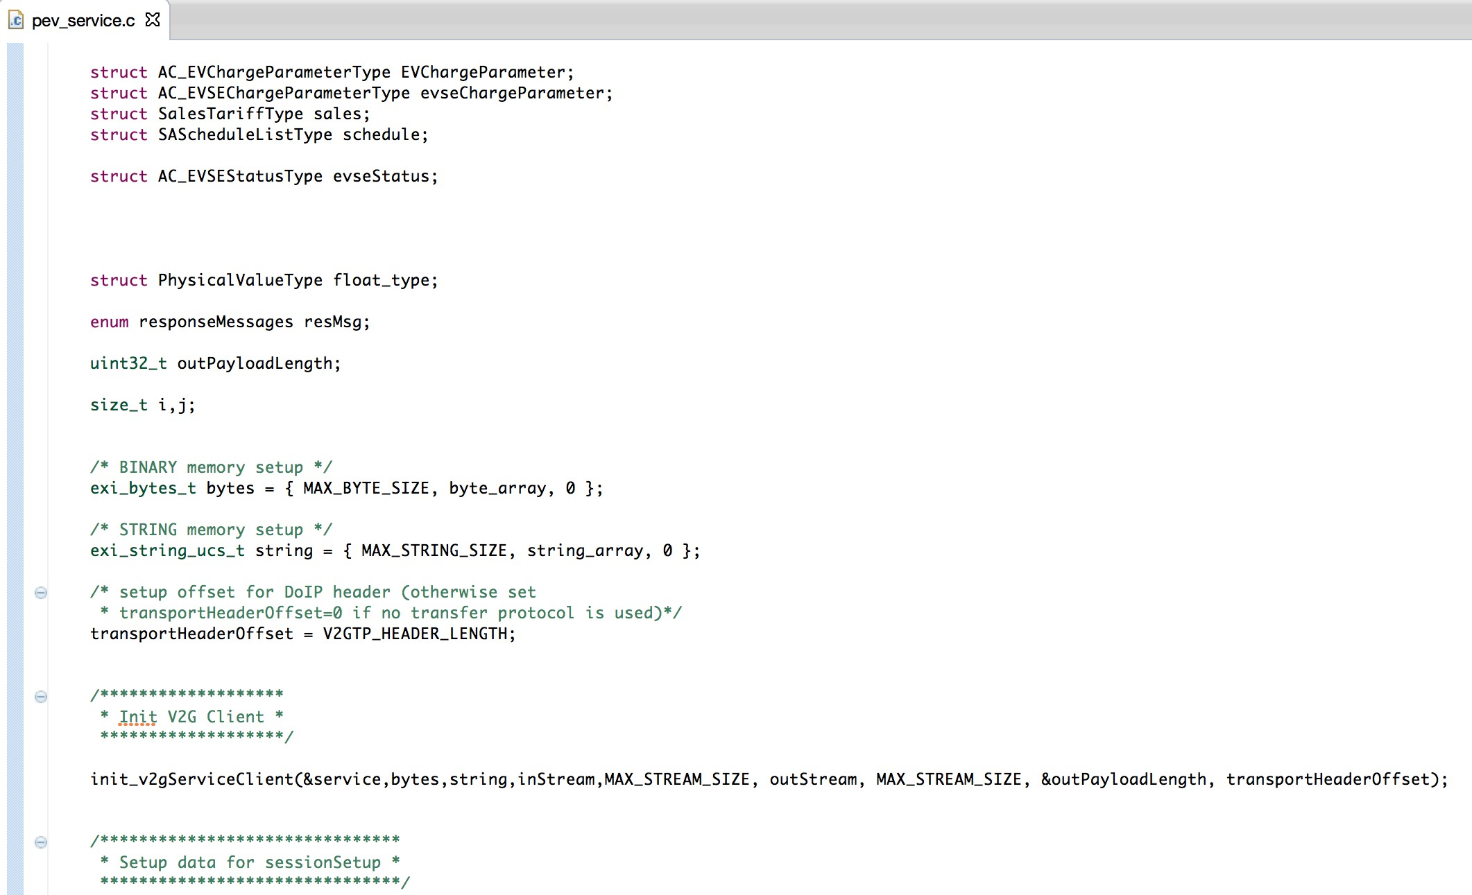

**Figure 23: Example Program Picture 6**

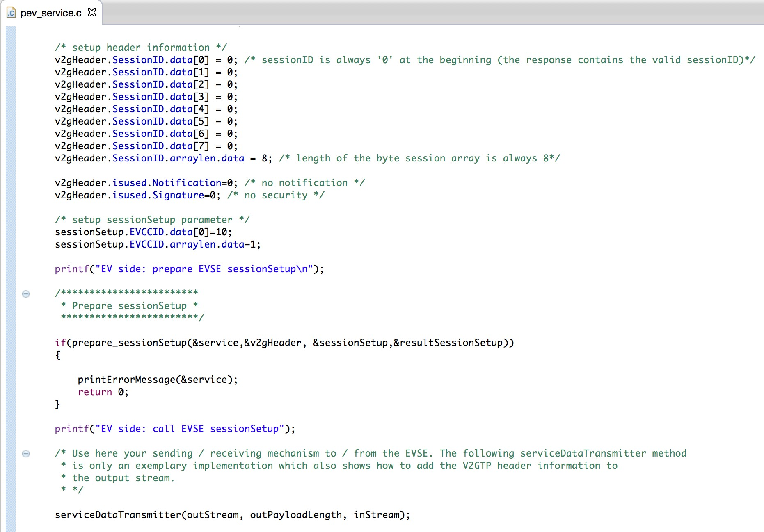

**Figure 24: Example Program Picture 7**

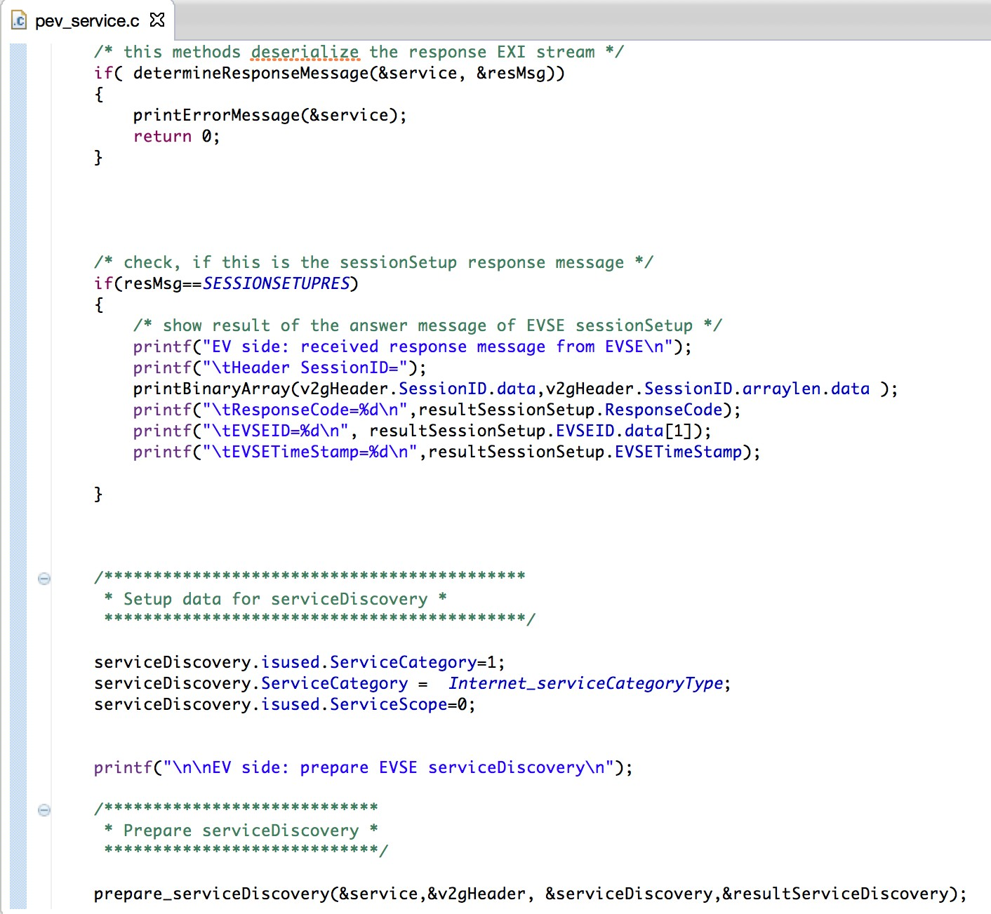

**Figure 25: Example Program Picture 8**

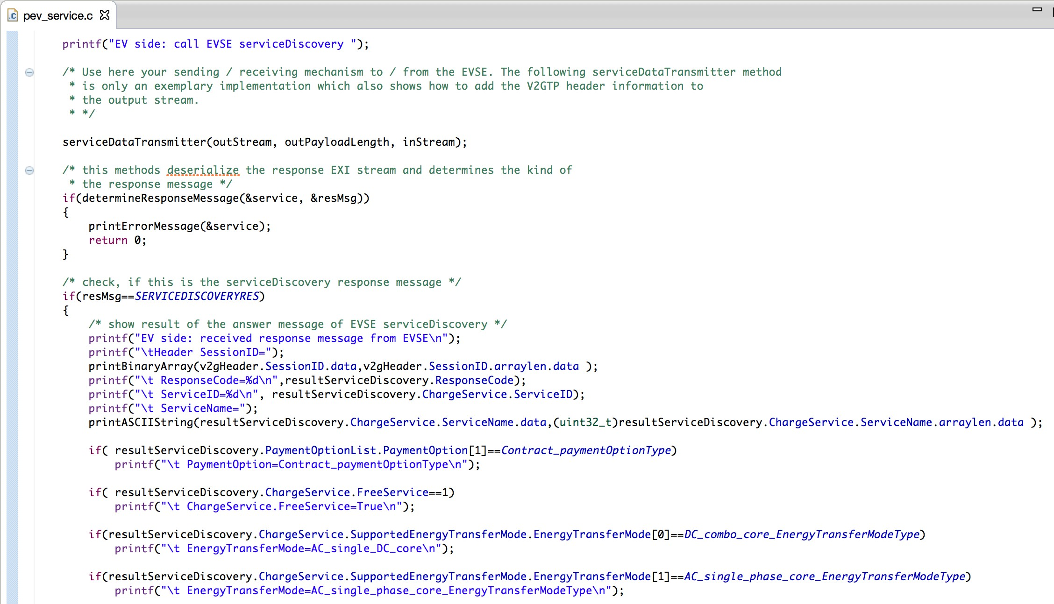

**Figure 26: Example Program Picture 9**

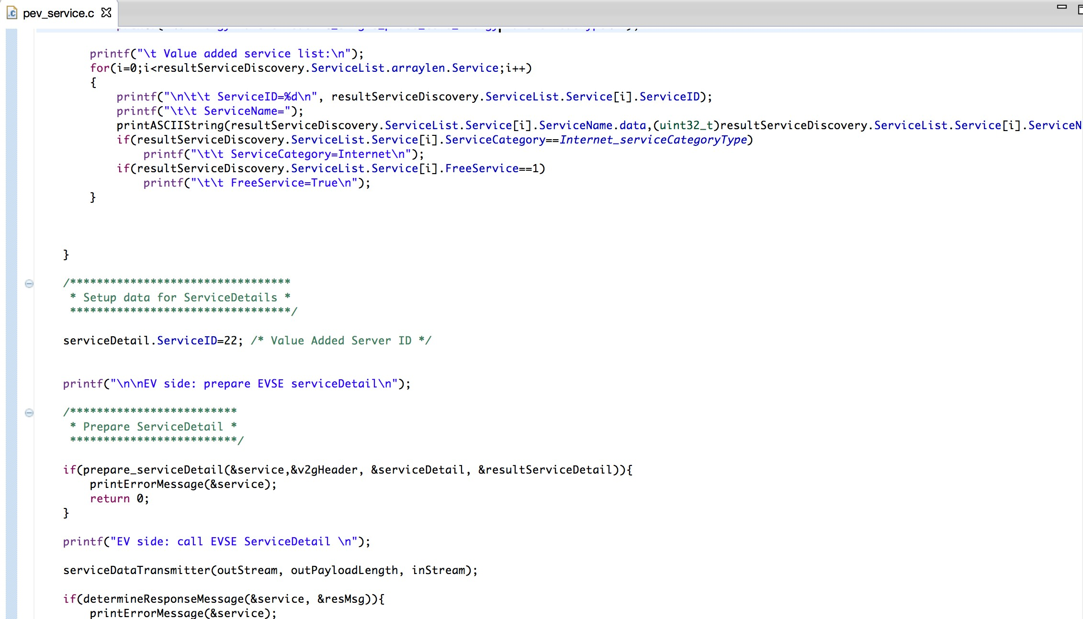

**Figure 27: Example Program Picture 10**

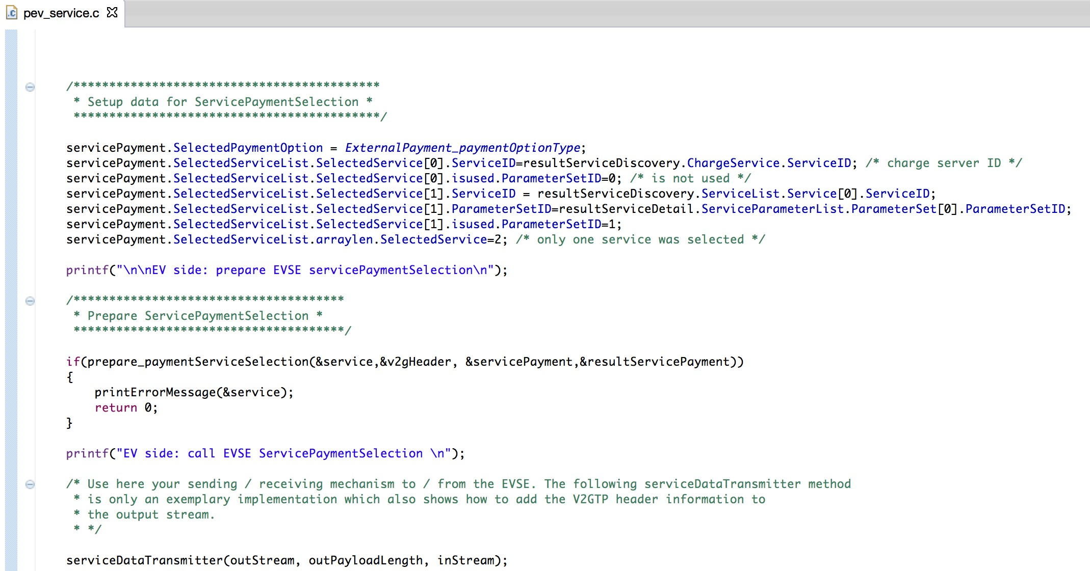

**Figure 28: Example Program Picture 11**